Sigmoid Function & Logistic Regression — Extended Lab
1-Page Summary Report
Problem Statement
Binary classification requires mapping unbounded linear scores to probabilities in (0,1) and then to hard labels. The classic Coursera C1_W3 optional lab introduces the sigmoid (logistic) function and its use inside logistic regression on a simple 1-D tumor-size example. Learners need a reproducible, extended practice environment that includes alternate implementations, threshold exploration, Monte-Carlo-style simulation, and clear guidance on what the model can and cannot predict.
Solution Strategy
1) Implement vectorized sigmoid and the logistic predictor f(x)=g(wx+b). 2) Visualize the S-shaped curve and the 1-D decision surface on the tumor toy data. 3) Provide pure-Python, SciPy-expit and numerically-stable alternates. 4) Add threshold-sensitivity and label-noise simulation cells so parameters can be edited interactively. 5) Supply a reusable template with a tiny gradient-descent fitter and bootstrap evaluation. 6) Document limitations and responsible-use notes tailored to different audience data-literacy levels.
Solution
Core implementation: g(z)=1/(1+e^{-z}); probabilities for the six-point tumor example with w≈1.8, b≈-5.4 recover the correct labels at τ=0.5. Simulation shows accuracy is maximized near τ=0.5 on balanced data and degrades under label noise. Flowchart and dual-panel overview plots are included below.
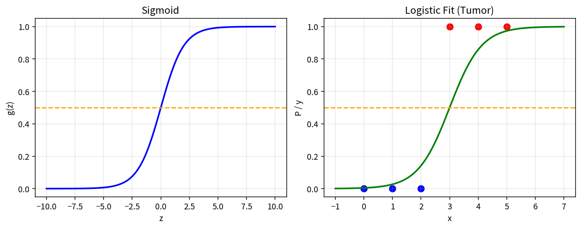
Key Takeaways
• Sigmoid is the essential link between linear scores and probabilities for binary outcomes.
• Threshold choice is a business / ethical decision, not a purely statistical one; lower τ increases sensitivity.
• The basic model yields linear decision boundaries in feature space and cannot claim causality or multi-class outputs without extension.
• Always validate, monitor drift, and adapt communication to the audience’s data literacy and subject knowledge.
Artifacts: Practice_Skeleton.ipynb · Solution.ipynb · Reusable_Template.ipynb · Cheatsheet · Responsible_Use_and_Applications.docx · flowchart & simulation PNGs

